**ABSTRACT**

Over the past two decades, researchers have become increasingly interested in dynamics. Longitudinal data structures are increasingly common and dynamic theories and hypotheses enter the literature every week. Despite more emphasis on dynamic relationships, researchers tend to discuss only a limited set of dynamic principles – like lags – or couch their thinking with respect to a specific statistical model – like growth curves. Our field has without question benefited from studies turning to longitudinal data and exploring some dynamic ideas, but there are many more fundamental dynamic principles to consider. In this paper, we provide a host of dynamic principles to build consensus on what it means to take a dynamic perspective and provide new opportunities for researchers to emphasize as we enter this domain.

INTRODUCTION

Think about how common it is to find phrases about dynamics scattered throughout an introduction to an article, phrases like “we are going to address the dynamics,” “taking a dynamic perspective,” “prior research has not appreciated the dynamics,” “we consider the phenomenon as dynamic,” or “we examine it on a dynamic basis.” What do these mean? How do researchers take a dynamic perspective?

Dynamics refers to a specific branch of mathematics/mechanics where the fundamental concept is that the past constrains future behavior (Boulding, 1955; Flytzanis, 1976; Simon, 1991). Researchers tend to study dynamics, however, with respect to a statistical model or class of models. For example, researchers that are familiar with growth models will talk about the importance of growth in a variable or how within-person trajectories have been ignored in prior research, they will then estimate a growth curve and ultimately convey something about trend or growth over time and how this result has added a new dynamic perspective to our understanding (e.g., Dunford, Shipp, Boss, Angermeier, & Boss, 2012; Hülsheger, 2016). “Growth model thinking,” as well as other recent ways of discussing phenomena over time, have produced great insights into important processes in organizational science and we see them as initial steps toward dynamics. Ultimately, though, they miss many fundamental principles of dynamics.

When researchers couch their thinking in a particular statistical model some concepts naturally go unnoticed. Our field is accumulating tremendous knowledge by collecting longitudinal data, focusing on how things happen over time, and opening the door of dynamics, but there are dynamic principles that have yet to be exposed in our literature – researchers have not yet stepped fully through the door. In this paper, we discuss a variety of dynamics principles; some are concepts that will reorient how researchers think about dynamics and others are statistical properties that, if ignored, result in biased inferences. Ultimately, we bring attention to principles that should be incorporated if researchers are interested in a dynamic perspective irrespective of the specific statistical model that they employ.

Through this endeavor, we make three specific contributions. First, we explicitly define dynamic principles to build consensus on what researchers should be expected to discuss and assess when they argue that they “address the dynamics” or “take a dynamic perspective.” We refer mostly to literature from organizational behavior/psychology because our primary purpose is to contribute to the applied psychological literature, but our arguments apply to other audiences as well. We move the field from an unorganized, small set of ideas couched in particular statistical models to a fundamental set of principles that will help researchers understand and communicate dynamics. Second, we reduce the gap some researchers may feel due to their interest in dynamics but limited exposure to mathematics in their graduate training. By finding a middle ground between overwhelming mathematics at one extreme and an informal, abstract glossing over of concepts at the other, we hope to gently guide researchers to a more formal understanding of dynamic principles. Finally, we highlight opportunities that researchers can take to appreciate dynamics with data that exist already – in many cases, the jump to dynamic thinking does not necessarily require an entirely new data set.

Below, we first discuss two broad classes of “thinking with respect to a statistical model” that have done much of the hard work – they are sets of empirical studies from organizational behavior/psychology taking initial steps towards dynamics. The first we call “growth,” and the second “relationships,” and we discuss example studies in each to briefly show our field’s interest in dynamics and how researchers approach it. These first two sections are not exhaustive, we simply sample the common ways researchers currently think about dynamics to motivate the core of the paper. There, we unpack the principles of dynamics.

# Stepping Toward Dynamics – Growth

One of the first steps our field is taking toward dynamic thinking is by examining whether something goes up or down over time – examining trend or growth patterns.

Hülsheger (2016) explores fatigue trends. He motivates his study by stating that his examination of the “the continuous ebb and flow of fatigue over the course of the day and about the factors that influence this temporal ebb and flow” responds to calls to “empirically address the dynamic process of recovery and thereby helps refine recovery theory” (p. 906). For five consecutive workdays, he assesses fatigue with self-report surveys – one in the morning, another at the first work break, a third at the end of work, and the last in the evening – among a sample of Dutch employees. All surveys measure fatigue and the morning survey also assessses sleep quality whereas the fourth measures psychological detachment. He examines his questions via growth-curve modeling, estimates fatigue growth curves, and correlates sleep quality and psychological detachment with both the fatigue intercept and slope, respectively.

Dunford et al. (2012) examine burnout trajectories over two years. They motivate their study by stating that, “theoretically, much of the burnout literature suggests that burnout should be progressive and dynamic, yet most empirical research has focused on explaining and testing the antecedents of static levels of burnout,” therefore “knowing for whom burnout changes and when this pattern of change occurs leads to a more realistic view of the dynamism of human experience” (p. 637). Over two years, they assess healthcare workers with five measurements, each separated by six months. All surveys measure burnout and the researchers also collect between-person assessments of job transitions (a categorical variable indicating whether an employee is a newcomer, recently underwent an internal job change, or remained at the same position throughout). They estimate a sequence of growth curves and examine linear and quadratic slope terms for all three burnout dimensions. They also covary job transition type with the intercept and slope terms.

## Summary

These authors are clearly interested in dynamics and in this framework they examine whether trajectories exhibit trends (growth), between-person differences in trend, and correlate other variables with those trends.

# Stepping Toward Dynamics – Relationships

Another popular approach to “getting dynamic” is to examine relationships across time rather than trends or covariates of trend.

Gabriel, Koopman, Rosen, and Johnson (2018) study the association among helping acts, depletion, and self-serving political acts. They motivate their study by highlighting the limitations of between-person research and then state that “a more appropriate empirical test of this process requires an intraindividual lens… That is, not assessing the dynamic relations between helping behaviors and related constructs potentially misaligns the theoretical underpinnings of the construct and the level of analysis used to assess their relationships (i.e., taking dynamic processes and assessing them with static, ‘in general’ assessments of constructs; Klein & Kozlowski, 2000)” (p. 2). For ten work days, they collect surveys twice a day (morning and afternoon). Both the morning and afternoon surveys assess helping acts, depletion, and political acts. They regress afternoon depletion on afternoon helping acts and morning depletion, and they regress afternoon political acts on afternoon depletion and morning political acts.

Johnson, Lanaj, and Barnes (2014) study relationships between justice behaviors, depletion, and OCBs – they argue that exhibiting procedural justice behaviors is depleting and can negatively influence OCBs. They motivate their study by stating that our current justice knowledge comes from “cross-sectional studies examining between-person differences,” but “there is a need for longitudinal, daily investigations of justice experiences that take a dynamic person-centric view” (p. 1). Ultimately they argue that their research design enabled them to “examine dynamic, within-person effects” and test a model “via a more granular approach to time” (p. 11). Their participants responded to surveys twice a day for 10 working days (morning and afternoon). The morning survey measured sleep quantity, whereas the afternoon survey measured justice behaviors, depletion, and OCBs. They regress afternoon depletion on the morning sleep quantity, the prior day’s afternoon justice behavior, and the prior day’s afternoon depletion.

Rosen, Koopman, Gabriel, and Johnson (2016) explore the relationship between incivility and self-control. They motivate their research by stating that “although examinations of incivility have gained momentum in organizational research, theory and empirical tests involving dynamic, within-person processes associated with this negative interpersonal behavior are limited” (p. 1). They also argue that “previous studies focused almost exclusively on chronic forms of incivility that occur on average during unspecified periods of time, which overlooks the dynamic and temporal nature of incivility and its effects. Consistent with ego depletion theory, we consider a dynamic process that explains why employees become more uncivil.” (p. 2). Their participants respond to three surveys a day (morning, afternoon, and evening) for 10 workdays. The morning survey assesses self-control, the afternoon survey assesses self-control, experienced incivlity, and instigated incivility, and the evening survey measures experienced incivility and instigated incivility. They regress afternoon self-control on afternoon incivility and morning self-control. Another model regresses evening incivility on afternoon self-control.

Koopman, Lanaj, and Scott (2016) examine the costs and benefits of OCBs on behalf of the actor – specifically how OCBs relate to positive affect and work goal progress. They motivate their study by stating that they “respond to calls in the literature to examine the consequences of OCB on a more dynamic basis” (p. 415). Their respondents fill out three surveys (morning, afternoon, and evening) for ten workdays. The morning survey assesses OCBs, positive affect, and work goal progress. The afternoon survey measures work goal progress and the evening survey assesses outcome variables irrelevant to the discussion here. They examine the relationship between OCBs and positive affect by regressing afternoon positive affect on morning OCB and morning work goal progress. They examine the relationship between OCBs and work goal progress by regressing afternoon work goal progress on morning OCB and morning work goal progress.

## Summary

These authors are also interested in dynamics. All test for within-person variance and motivate their studies by stating that “the good stuff” resides in the within-person relationships. They collect many observations given their frequent sampling design and examine concurrent or lagged relationships across their variables over time.

# Opening the Door to Dynamics

The point of highlighting the studies above was to sample common ways empirical researchers in applied psychology approach dynamics. Both frameworks are valuable, they move beyond cross-sectional research, address new and interesting questions, and consider great notions such as growth, relationship patterns over time, between and within-person variance comparisons, and inter-individual differences in intra-individual trend. But the concepts that receive majority attention are couched in specific statistical models and some, as we argue below, are actually not dynamics. When ideas are couched in a specific statistical model they miss other fundamental concepts and emphasize observed, manifest results rather than the underlying process itself that produces the observed result. Describing dynamics with manifest results from specific statistical models rather than fundamental concepts about the underlying process is like trying to convey how an engine works by only describing its temperature trend. Dynamics is a much broader concept with principles that describe and characterize processes over time that merit attention irresspective of the specific statistical model employed by the researcher.

We provide a host of dynamic principles to create consensus on what it means to take a dynamic perspective. Some of the principles are concepts, ways of thinking that are necessary to appreciate as researchers and theorists explore dynamic phenomona. Others are statistical properties that arise when researchers apply models to longitudinal data structures – they are statistical issues that produce inferential errors if left unchecked and they are important across all types of longitudinal models. The dynamic perspective that we present will benefit researchers by allowing them to better conceptualize, study, and convey the dynamic characteristics of the underlying process rather than an observed result such as trend.

# Dynamics

Dynamics refers to a specific branch of mathematics/mechanics, but the term is used in different ways throughout our literature. It is used informally to mean “change”, “fluctuating,” “volatile,” “longitudinal,” or “over time” (among others), whereas formal definitions in our literature are presented within certain contexts. Wang (2016) defines a dynamic *model* as a “representation of a system that evolves over time. In particular it describes how the system evolves from a given state at time *t* to another state at time $t+1$ as governed by the transition rules and potential external inputs” (p. 242). Vancouver, Wang, and Li (2018) state that dynamic *variables* “behave as if they have memory; that is, their value at any one time depends somewhat on their previous value” (p. 604). Finally, Monge (1990) suggests that in dynamic *analyses*, “it is essential to know how variables depend upon their own past history” (p. 409).

The crucial notion to take from dynamics, then, is that the past matters and future states are constrained by where they were at prior points in time (Boulding, 1955; Flytzanis, 1976; Simon, 1991). Below, we unpack a number of important principles couched in this simple idea.

## Concepts and Conventions

These first principles are concepts to help researchers think about dynamics.

**States.** In organizational science we typically use the term “variable” to describe a measured construct and our lens is usually across people. Burnout, depletion, fatigue, OCBs, performance, job satisfaction – these are all variables; they are quantities with values that fluctuate across people. When we instead focus on how those values fluctuate across time we call them “states.” Performance as a variable, therefore, focuses on the set of values across people, whereas performance as a state focuses on its values across time.

Researchers have indirectly called attention to the dynamic notion of states by distinguishing traits, or stable individual differences, from states. This distinction is prevalent in personality resarch (e.g., Dalal et al., 2015 ; Hamaker, Nesselroade, & Molenaar, 2007 ), but also emerges in motivation (e.g., Beck & Schmidt, 2013; Dragoni, 2005) and emotion (e.g., Miner & Glomb, 2010) research, among others.

The convention to label states is to use what is called a state vector. A state vector for depletion, fatigue, and performance would be: (depletion, fatigue, performance) and its mathematical equivalent is, $(x_{1},x_{2},x_{3})$ or $(x_{1}...x_{n})$. We will use this notation later after introducing more concepts.

**Memory and Self-similarity.** A fundamental concept in dynamics is that states often have memory – they are self-similar across time. Individual, dyadic, and team performance may vary or fluctuate over time, but they retain self-similarity from one moment to the next. Job satisfaction now is some function of what it was just prior to now. My conscientiousness tomorrow will have carry over from what it was today, as will the number of people I communicate with. Researchers of course may argue that some states have no memory, but the point here is that states tend to retain something about what they are from moment to moment.

**Constraints.** When a state has memory or self-similarity it can still fluctuate or change over time – to say that Rachel’s job satisfaction will predict itself over time does not mean that we expect her job satisfaction to be identical every day. Instead, it will fluctuate or vary but under the constraints of where it was in the past. Imagine we argue that job satisfaction has no memory. If we grant that statement, then Rachel’s job satisfaction from moment to moment is unconstrained and it can swing (potentially) to positive or negative infinity based the states that cause it. But if it does have memory then it is constrained, it cannot swing explosively. When she experiences something negative at work – like ridicule – her job satisfaction will certainly decrease in the moment, but what is her job satisfaction decreasing from? The answer is its prior level – the negative experience is pushing against her prior level of job satisfaction, job satisfaction is not created from scratch just after ridicule. States vary over time, but where they go is constrained by their history.

It is also helpful to consider what would happen if we vary the strength of Rachel’s job satisfaction memory. Imagine that her job satisfaction is only weakly self-similar. When she then experiences ridicule we would expect her satisfaction to fluctuate to a large extent, decreasing considerably with respect to the strength of the ridicule. When instead her satisfaction is strongly self-similar the ridicule would not lower it to the same degree.

**Lags.** Memory is not limited to a single variable. Job satisfaction may also be influenced by the prior history of other states like, for example, autonomy, fatigue, and co-worker support. Imagine we believe that fatigue has a lag effect on performance, where the influence of fatigue on performance does not happen immediately but instead after some period of time. Despite collecting longitudinal data many researchers still examine concurrent relationships by regressing DVs on IVs at the same moment. That is, they regress performance at time four on fatigue at time four and performance at time six on fatigue at time six despite having the possibility to explore lag effects. What these concurrent models imply is that the researcher expects fatigue to instantaneously influence performance. With some states immediate cause makes sense, but as our “over time” thinking progresses there will be many opportunities to explore lags.

**Reciprocal Influence.** Many research questions can be boiled down to trying to find antecedents and outcomes, but when we focus on dynamics and start thinking about memory, constraints, and lags across multiple states we focus less on “true causes” or antecendents and more on reciprocal influence. This kind of thinking often takes the form, “and then this happens.” Consider the (example) reciprocal relationships between performance, superior support, and fatigue. I perform my assignment well so my boss sends a nice email letting me know that she appreciates my work. Feeling inspired, I subsequently increase my performance and again perform well on my second assignment. Having increased my performance, however, I am now more fatigued and on my third assignment I perform poorly – and this poor performance is not followed by another congratulatory email. In this simple example, performance, fatigue, and superior support fluctuate across time. We are not necessarily interested in finding the “true” cause, direction of effects, or the exact coefficient between one state and another, but instead the pattern of reciprocal relationships across time.

### Timescales. Timescales are an important concept in systems with lags, memory, constraints, and reciprocal influence. Even within one phenomenon, effects can occur on different timescales. Consider the temperature of a building. The quick dynamics occur from room to room, where air molecules pass between rooms until all are roughly the same temperature. The exterior weather, conversely, influences the building under a different, delayed timescale. Heat confronts the exterior walls, warms them, and ultimately influences the entire building only after a much longer period of time than the interior air-flow.

Mathieu and Taylor (2006) provide another timescales example with respect to employee motivation. “Consider a work redesign effort intended to empower employees and thereby to enhance their work motivation with the aim of increasing customer satisfaction. How long does it take to establish the new work design? If employees are indeed more motivated to perform, how long will it take for customers to notice and for them to become more satisfied?” (p. 1035). Note that we are emphasizing the timescales of the underlying phenomena, not measurement timing. Measurement timing is of course an important issue but it has received attention elsewhere (James, Mulaik, & Brett, 1982; Kenny, 1979).

**Boundary Space.** When researchers estimate a growth curve and argue for a positive linear trend they are implying that the trajectory increases forever. Job satisfaction perpetually increases; OCBs go down endlessly. In dynamic systems with reciprocal influence and constraints, there are boundaries on where processes can go. Communication may fluctuate day to day, and it may even increase steadily as an employee transitions into a new role, but it is unlikely that it will continue to increase or decrease without bound forever. Estimating a quadratic term does not resolve this issue. A predicted quadratic line can appear to level-off, but it appears so because the prediction line is cut-off by the number of observed time points in the study – a quadratic term implies a full U-shaped trajectory.

**Initial Conditions.** The last concept is that initial conditions may or may not influence the overall dynamics. Imagine an employee’s climate perceptions fluctuating over time and showing a reciprocal pattern with a number of other important states. The dynamics of his climate perceptions may depend on his first encounters with the company – his initial perceptions. Perhaps his initial perceptions were positive and over time showed reciprocal patterns with performance, dyadic social exchanges, burnout, and leadership perceptions. A researcher paying attention to initial conditions would examine if those same reciprocal patterns emerge under different starting conditions, like a bad first encounter.

An example is in Liebovitch, Vallacher, and Michaels (2010) explanation and model of conflict and cooperation between two actors. Their explanation involves three states in a two-person situation, including (1) each individual’s general affective state, (2) feedback from one person to the other, and (3) each individual’s general tendency to change based on the feedback. They argue that the patterns of conflict and cooperation that two individuals demonstrate over time differ dramatically if both individuals start with the same affective tone (positive and positive or negative and negative) versus opposing tones – that is, the dynamics of conflict and cooperation are sensitive to the initial conditions of the actors involved.

**Describing Trajectories.** In this paper, we introduce concepts and statistical properties that merit attention as we approach dynamics. Readers should also see a paper by Monge (1990) that provides basic vocabulary for describing trajectories. He discusses terms like trend, periodicity, and cycles – lexicon for patterns over time rather than key concepts that are emphasized here. We feel that his paper should be required reading for anyone interested in dynamics.

## Mathematics and Statistics

We now translate some of the concepts into math. Doing so (a) reiterates the principles above, (b) introduces new dynamic principles, and (c) makes it easier to talk about some of the more complicated statistical properties of dynamic modeling that we turn to in the final section.

Remember that dynamics emphasizes memory, self-similarity, and constraints as states move across time. Here, we capture those ideas with equations using performance as an example. First, consider performance across time:

${Performance}_{t}={Performance}_{t-1}$ (1)

where performance at time $t$ is exactly identical to what it was at $t-1$. This equation says that performance does not fluctuate, change, move, or grow across time – there is zero trend. Performance is, say, four at time one, four at time two, four at time three, and so on. This type of equation is called a difference equation, and it is a foundational tool in dynamics.

Although this first equation seems deceptively simple, we already captured memory. Performance in this case is perfectly self-similar. What if, instead, performance is similar but not perfectly self-similar across time? To capture this idea we need a new term:

${Performance}_{t}=a*{Performance}_{t-1}$ (2)

where $a$ is the extent to which performance is self-similar and all other terms are defined above.

**Fundamental Behaviors.** There are fundamental behaviors of dynamic states based on their self-similarity or memory terms and these are shown in Figure one. The top row of Figure one shows the trajectory of states with terms that are greater than one in absolute value. These large terms produce explosive behavior – exponential growth when $a$ is positive and extreme oscillations when $a$ is negative. When the term falls between zero and one in absolute value, conversely, the state converges to equilibrium – shown in the bottom two panels. Either the state oscillates at a decreasing rate until it reaches equilibrium (when $a$ is negative) or it converges there smoothly (when $a$ is positive). Again, these behaviors hold for all states given the respective self-similarity terms shown in the Figure.

—————

Insert Figure 1 About Here

—————

**Equilibrium.** Notice that we introduced a new word in our description above: equilibrium. Equilibrium describes the state of a variable that no longer changes unless disturbed by an outside force. It can also be used to describe multiple variable systems – where equilibrium again means that the state remains constant unless disturbed by an outside force, but here state refers to the the entire system (i.e., all of the variables). In *static* equilibriums, the system has reached a point of stability with no change, whereas *dynamic* equilibrium refers to systems with changes and fluctuations but no net change. That is, the variables fluctuate across time in periodic ways but the general state of the system does not diverge so as to change the behavior of the entire system.

Predator-prey relationships are a typical example of a system in dynamic equilibrium. For example, consider a predator-prey relationship between bobcats and rabbits. As the rabbit population increases, the amount of available food for the bobcats goes up. Over time, this raises the population of the bobcats as well. Now with a greater bobcat population, the rabbit population decreases because more are being killed. Over time, this reduction in food decreases the bobcat population. The back and forth oscillating pattern is the outcome of a state system in dynamic equilibrium, where despite random disturbances across time the net dynamics of the states remain stable.

### Stochastics. Our route so far has been deterministic – the mathematical representations do not contain error. Stochastics, stated simply, refers to processes with error and there are a host of additional principles to consider once error enters the conceptual space. Consider the difference equation from above, adding an error component produces:

${Performance}_{t}=a*{Performance}_{t-1}+e_{t}$ (3)

where all terms are defined above but $e_{t}$ represents an error term that is incorporated into performance at each time point. Errors cause performance to be higher or lower at specific points in time than we would have expected given a deterministic process. For example, at time $t$ the error might push performance to a higher value and at $t+1$ to a lower value. Errors are therefore said to be random because we cannot predict their value at any specific $t$. In aggregation (i.e., averaged across time), however, positive errors cancel negative errors and large errors are less likely than small errors. In stochastic systems, therefore, the errors are said to be distributed $N(0,1)$– that is, random and unpredictable at any specific $t$ but distributed with certain constraints across time. It can also be helpful to think about what error is not. Anything that is systematic, predictable, or common (using those in layman’s terms) cannot be error – leaving error to be the random “left overs.”

**White Noise and Random Walks.** There are two fundamental stochastic processes: white noise and random walks. White noise is a process that only has error. Setting $a$ to zero in equation 3 produces a white noise process.

$\begin{matrix}{Performance}_{t} & =a*{Performance}_{t-1}+e_{t} \\ a & =0\end{matrix}$ (4)

Here, all we have is error over time; the lower panel of Figure 2 shows the behavior of a white noise process. Random walks are similar, but $a$ is now equal to one.

$\begin{matrix}{Performance}_{t} & =a*{Performance}_{t-1}+e_{t} \\ a & =1\end{matrix}$ (5)

This representation is also an error process but now error is not the only operator, performance retains self-similarity across time as well. The upper panel of Figure two presents a random walk. Although random walks can sometimes appear to be moving in a systematic direction, ultimately their behavior is unpredictable: they could go up or down at any moment.

Random walks and white noise are error processes over time. Both flucutate randomly, but random walks retain some self-similarity through time. These two principles are the null hypotheses of time-series analysis in econometrics – where the first task in a longitudinal study is to demonstrate that you are investigating something that is not a random walk or white noise. That is, if a researcher wanted to show the effect of IVs on performance across time they would first need to demonstrate that performance and all of their IVs are not random walks or white noise processes. This step is currently absent in our literature but, again, is the essential starting place in econometrics.

—————

Insert Figure 2 About Here

—————

**Dynamic Systems.** Up to this point we have focused on a single state, performance. Remember that dynamic perspectives also consider reciprocal influence, but before moving to two or more state equations notice how much researchers can explore with single states. It is of course interesting and fun to ask how two or more states are related or posit a complex sequence among a set of states. But understanding whether or not one state exhibits white noise or random walk behavior across time is a valuable study in itself. Our field could substantially benefit from spending more time plotting and analyzing the individual trajctories of every measured variable in a study.

With multivariate systems we need multiple equations – one for each state. Before, we demonstrated a simple difference equation for performance. In a multivariate system with two states, such as performance and effort, we need one equation for each.

${Performance}_{t}=a*{Performance}_{t-1}+e_{t}$ (6)

$${Effort}_{t}=a*{Effort}_{t-1}+e_{t}$$

Here, both equations posit that their state is a function of its prior self to the extent of the autoregressive term ($a$). Notice that there are no cross-relationships, we are simply representing a system with two independent variables over time. It is of course also possible to introduce relationships among the different states with more terms.

First, consider a system where effort concurrently causes performance, or where effort $​_{t}$ influences performance $​_{t}$:

${Performance}_{t}=a*{Performance}_{t-1}+b*{Effort}_{t}+e_{t}$ (7)

$${Effort}_{t}=a*{Effort}_{t-1}+e_{t}$$

where all terms are defined above but now the equation for performance also includes Effort $​_{t}$, which is the value of effort at time $t$, and $b$, the coefficient relating effort to performance. This set of equations says that effort is simply a product of itself over time (with error), whereas performance is a function of itself and also effort at the immediate time point.

What if effort causes performance after some lag? That is, perhaps we posit that effort does not immediately cause performance but instead causes performance after some period of time. If the lag effect were 2, that would mean that Effort $​_{t}$ causes Performance $​_{t+2}$, and to express the “lag 2 effect” mathematically we would use the following:

${Performance}_{t}=a*{Performance}_{t-1}+b*{Effort}_{t-2}+e_{t}$ (8)

$${Effort}_{t}=a*{Effort}_{t-1}+e_{t}$$

Here, all terms are nearly identical to what we saw above but now there is a lag-two effect from effort to performance. Performance is now a function of both its immediately prior self and the value of effort from two time points ago.

What if we want to convey feedback, or a reciprocal relationship between effort and performance? That is, now we posit that both effort causes performance and performance causes effort. To do so we update our equations with a simple change:

${Performance}_{t}=a*{Performance}_{t-1}+b*{Effort}_{t-2}+e_{t}$ (9)

$${Effort}_{t}=a*{Effort}_{t-1}+b*{Performance}_{t-2}+e_{t}$$

where all terms are defined above but now effort and performance are reciprocally related. Both are determined by themselves at the immediately prior time point and the other state two time points in the past. Effort happens and two moments later it influences performance, and two moments later performance goes back to influence effort, and so on throughout time. All the while, both states retain self-similarity – they fluctuate and develop but only under the constraints afforded by the autoregressive terms.

We can make the equations more complicated by continuing to add variables or longer/shorter lag effects, but the beauty of math is its freedom to capture whatever the researcher desires. These equations are language tools to help researchers convey dynamics. In addition, researchers who are interested in studying dynamic phenomena will likely find use in explicitly stating their hypothesized relationships in equation form. In general, language-based theorizing is good at description but struggles with specificity and complex relationships. The shortcomings of such theories can be amplified when a researcher attempts to discuss how variables interact dynamically over time because it is difficult for people to conceptualize how these systems develop as time iterates (Cronin, Gonzalez, & Sterman, 2009). Placing one’s theorizing into the actual underlying equations will help formalize and organize the researcher’s thoughts and assist in avoiding inferential and logical errors in the theory.

## Dynamic Modeling

Above, we introduced fundemental concepts for dynamics. Memory, constraints, initial conditions, equilibrium, reciprocal influence – these elements constitute the underlying dynamics and are ingredients to grapple with as researchers consider dynamic phenomenon. Dynamic mechanisms give rise to observed data, distributions, and statistical properties for us to witness and it is those observed data that we apply statistical models to. In a perfect world, researchers could put a magnifying glass up to their observed data and its statistical properties and clearly identify the underlying dynamics. Unfortunately we do not live in that world. Instead, there are a host of challenges that must be considered when researchers collect longitudinal data and estimate models to make inferences about dynamics. In this section we describe stationarity, dynamic panel bias, and ergodicity. Note that throughout the rest of the paper we replace the layman’s term for $a$ (self-similarity) with its more common name in the statistical literature: autoregression, serial correlation, or autocorrelation – all of these refer to the relationship between a state and itself over time.

**Stationarity.** States and systems have statistical properties, stationarity is about the stability of those properties. Rachel’s performance across time is called a time-series – it is the trajectory of performance for a single unit (Rachel) over time. That trajectory has properties: it has a mean and a variance (and autocorrelation or serial correlation). If the mean is unstable then Rachel’s performance either grows or decreases unconditionally over time. If instead the mean is stable, then Rachel’s performance across time fluctuates but within the constraints of its memory and bounds on the system. Growth models assume no stationarity in the data they model, whereas virtually all other models used in the applied organizational literature assume that the data they are modeling are realizations of a stationary process. That is, they assume that the states and systems they are trying to estimate parameters for have properties at time $t$ that are the same as the properties at time $t+1$.

In simple terms, a stationary process has stable properties across time – data that demonstrate trend, growth, or random walk behavior are (almost certainly) non-stationary. Here is the hard part: two independent time-series will appear related if both are non-stationary (Granger & Newbold, 1974; Kuljanin, Braun, & DeShon, 2011). That is, if we measure Rachel’s performance and it is consistent with a random walk and we also measure rainfall at Rachel’s mother’s house across the state and it demonstrates increasing trend for the day, even though these two things are completely unrelated we will more than likely find a relationship between them in a regression-based analysis like those presented at the start of this paper. There are many other articles that describe how to test for stationarity (e.g., Braun, Kuljanin, & DeShon, 2013; Jebb, Tay, Wang, & Huang, 2015), the point here is to convey how important this notion is. Our literature is not paying attention to random walks, we are not checking for memory, or serial correlation, or stationarity; we should be.

That said, there is a class of models known as cointegration models that can be used to evaluate relationships in a non-stationary system. They are more complicated and require a deep understanding of mathematics and econometric modeling, but interested readers can see Engle and Granger (1987), Johansen (1991), Phillips (1991), Phillips and Hansen (1990), and Phillips and Durlauf (1986).

Again, stationarity describes statistical properties that result from the underlying dynamics. States may or may not have memory, they may or may not have lag relationships, or reciprocal influence, and may or may not be constrained by their initial conditions. These aspects are the underlying dynamics and the distributions that they give rise to have properties, stationarity is about those emergent statistical properties. Any system in equilibrium will be stationary, whereas unstable systems will be non-stationary.

**Dynamic Panel Bias.** Another challenge for dynamic modeling is dynamic panel bias, which is the combined effect of two issues. The first issue has to do with statistically accounting for memory. Remember that the dynamic equations above took the form:

$y_{t}=ay_{t-1}+e_{t}$ (10)

where the only change is that we replaced performance with a generic $y$. The equation above has what is called a “lagged DV,” where $y_{t}$ is predicted by the lagged DV: $y_{t-1}$. Including lagged DVs helps us *conceptually* represent dynamics (Keele & Kelly, 2006), but including a lagged DV in a *model* applied to data with actual statistical properties causes the errors to correlate with the predictors and ultimately violate the well-known independence of errors assumption. This issue applies even when we are only considering a single unit (like Rachel) across time.

The second issue arises when we are interested in relationships with a multiple-unit sample across time. Almost all organizational studies are multiple-unit – they collect data on more than one participant. If the people in the sample are not perfectly exchangeable, which means that we can learn the same thing about performance and fatigue by studying either Bob or Rachel, we lose no information by restricting our analysis to one of them, then the parameter estimates are influenced by what is known as unobserved heterogeneity. Unobserved heterogeneity represents aggregate, stable individual differences. Rachel’s fatigue over time may look different from Bob’s fatigue over time due to unmeasured individual differences and states. These unacknowledged effects are responsible for individual differences on fatigue so they need to be incorporated in statistical models. We acknowledge them by incoporating unobserved heterogeneity, again it is a term that is meant to represent all of the unmeasured things that make Rachel’s trajectory different from Bob’s trajectory.

In dynamic modeling, unobserved heterogeneity must be handled appropriately: if it is modeled as independent but in fact correlates with the model predictors then ommitted variables bias is introduced into the estimates, and if unobserved heterogeneity is ignored then serial correlation will be introduced into the errors.

Dynamic panel bias is the combined effect of these two biases. Lagged DVs conceptually convey a dynamic process but they create estimation problems and researchers must account for unobserved heterogeneity. Unfortunately, the current workhorse in our literature to examine dynamic phenomena (the hierarchical linear, random-coefficient, or multi level model) is not well suited to handle dynamic panel bias.

### Ergodicity. In the section above we spoke about unobserved heterogeneity, which can be thought of as heterogeneity of individual differences or unit effects. That is, there are unmeasured differences that result in Rachel’s trajectory being different from Bob’s. An appropriate next question is, when is it reasonable to pool Rachel and Bob’s data? When can we be confident in homogeneity of dynamics? This is the notion of ergodicity.

Ergodicity is another statistical characteristic of a process, and it is important because it determines whether or not researchers can generalize inferences of inter-individual variability from tests of between-unit differences to inferences of within-unit variability. To see the dilemma, consider the following. First, the standard statistical models in applied psychology and management, such as growth curves, multi-level models, mixture modeling, ANOVA, and factor analysis all focus on between-unit variation (Molenaar, 2004). Second, researchers using these techniques run their computations on a sample drawn from a population and then generalize their results back to the population, so (a) the results live at the level of the population and (b) researchers assume that the population (or sub population in mixture modeling) is homogenous (Molenaar & Campbell, 2009). These notions are fine on their own, but researchers tend to make an additional assumption that is unlikely to hold: because resuls live at the level of the population and because researchers assume that the population is homogenous they often also assume that the results apply to the individuals making up the population (Molenaar, 2008b). In other words, they assume that the results from a test of between-unit variation hold at the level of within-individual variation.

When processes are ergodic, this implicit assumption holds: the results of an analysis of between-unit differences generalize to within-unit patterns and vice versa (Molenaar, 2007, 2008a). Researchers can generalize with ergodic processes, they can use a multi-level model to assess between-unit patterns and then make statements about within-person relationships. But this generalization is rarely appropriate. A Gaussian process is non-ergodic if it is non-stationarity (e.g., it has time-varying trends) and/or heterogeneous across subjects (subject-specific dynamics). Stated simply, a Gaussian process is non-ergodic if it has trend and/or Susie’s trajectory is different from Bob’s. If either is violated, which is often the case, then standard analyses of between-subject differences (growth models, multi-level or random-coefficient models, mixture models, ANOVA, factor analysis) cannot be used to make within-person statements. In general, within-person inferences need to come from unpooled, subject-specific time-series data structures (Molenaar, 2009). The general notion to take from ergodicity (which merits greater discussion elsewhere) is that researchers need to pay attention to homogeneity of dynamics across units.

# Discussion - A Dynamic Perspective

We opened this paper by discussing how researchers in applied psychology and organizational behavior are beginning to approach dynamics. We pointed to two frameworks – growth and relationships – as examples of empirical research doing the hard work of getting our thinking beyond static, cross-sectional associations. They were appropriate first steps toward dynamics given our field’s history with random coefficient models and more recent emphasis on growth curve modeling, but there are many dynamic principles outside the context of a specific longitudinal model – we presented them here. Taking a dynamic perspective means focusing on memory, constraints, timescales, reciprocal influence, initial conditions, and exploring an array of satistical properties like serial correlation and stationarity. Taking a dynamic perspective means being seriously concerned that your trajectory is not simply a random walk or white noise process.

We close this paper with three short, unique sections to solidify the principles and what we mean by a dynamic perspective. In the first section we highlight recent dynamic studies that explore some of the principles discussed here. Then, we consider what dynamics is not. We conclude by presenting the linear dynamic systems model as the fundamental framework for dynamic investigations.

## Recent Work

There are several great studies already exploring some of the key dynamic properties. To get a sense for this literature and to highlight the principles that they capture, we searched for empirical studies that were (1) published in the last five years (2) in the *Journal of Management*, *Journal of Applied Psychology*, or *Academy of Management Journal* and (3) contained “dynamic” or “dynamics” in the title. We exclude research that is cross-sectional, ethnographic, or focuses only on growth/covariates of growth. The articles and the dynamic notions that they emphasize are listed in Table one.

The studies as a whole explore a number of dynamic principles. First, every study emphasizes lags – they evaluate associations, influence, and patterns from current states to subsequent states, or prior states to current states. For example, Hardy, Day, and Steele (2018) examine the relationship between self-efficacy and subsequent exploratory behavior, the relationship between prior exploratory behavior and subsequent metacognition, and the relationship between self-efficacy and subsequent exploratory behavior (among others). Jones et al. (2016) study the relationship between revealing behaviors among pregnant women and subsequent physical health symptoms. Many also discuss serial correlation, autocorrelation, or autoregression. Gabriel and Diefendorff (2015) assess autocorrelations ranging from T-1 to T-20 seconds and their Table one demonstrates how autocorrelation coefficients for emotion decrease in size over longer lags (i.e., emotions show stronger self-similarity when they are related to $t-1$ emotions versus $t-20$ emotions). Finally, a number of studies explore reciprocal patterns over time and a few discuss unobserved heterogeneity indirectly by using a statistical test to determine if they should employ a fixed or random effects model (i.e., a Hausman test). These are recent, exciting dynamic perspectives that our literature is beginning to expose.

Notice, however, that we also include an “opportunities” column in Table one that highlights the principles that could be examined with the data that currently exist but are not discussed in each article. Although researchers are thinking about lags and autocorrelation, there are other principles like initial conditions, equilibrium, timescales, random walks, stationarity, and ergodicity that have yet to be explored and are great opportunities to discover even more dynamics. We also noticed that many of the studies that assess autocorrelation do not have conceptual discussions about memory or self-similarity or constraints, but instead assess autocorrelation as a statistical hurdle to overcome before discussing the lag relationship of interest. It is certainly appropriate to assess – especially to avoid inferential errors – but finding evidence of memory in a state is useful knowledge on its own and helps build theoretical understanding.

—————

Insert Table 1 About Here

—————

Finally, many of the principles that we highlight as opportunities do not require grueling extra work. Rather, they can be examined with the data that already exist to (a) learn more about the system and (b) deter inferential errors. We hope this paper will ignite more study into the principles described.

## What Dynamics Is Not

During a time when authors were discussing what constitues theory, Sutton and Staw (1995) produced a useful article describing what theory is not – it is a conerstone reading for management, organizational behavior, human resources, and organizational psychology programs across the country. A similar approach may be useful here, where addressing what dynamics is not could help researchers fully grasp its content.

**Time as a predictor is not dynamics.** Our field has a number of great papers discussing the idea that time cannot be causal. Ployhart and colleagues have probably said it best: “constructs do not change, evolve, or develop because of time; rather they do so over time. For example, time does not cause children to grow into adults. Even though time is highly related to physical growth, the causes of growth are genetics and environment” (Ployhart & Vandenberg, 2010, p. 98). Moreover, our theories do not specify time as a causal variable but instead specify that changes happen over time due to other causes (Pitariu & Ployhart, 2010).

We agree with these statements but extend them slightly to encompass a dynamic perspective. Imagine a study that evokes time as a moderator and then makes a conclusion like, “early on A happens, whereas later on B happens.” They do not discuss time as the cause, but they do argue that they are studying dynamics because state behaviors differ at time 3 compared to time 2. Identifying that time 3 states and relationship patterns are different from those at time 2 is useful, but it is not dynamics, it is not characterizing how past behavior constrains new state patterns or how states from one moment reach others at subsequent moments. In concrete terms, finding that job satisfaction is high for newcomers and low for old-timers is not dynamics, neither is recognizing that it positively relates to performance during week one but negatively relates to performance after a month on the job. Dynamics is studying how job satisfaction unfolds through time based on its constraints, self-similarity, initial conditions, and reciprocal sources of influence.

**Static relationships across time are not dynamics.** Longitudinal data do not automatically make the focus of a study dynamics. Many studies that collect longitudinal data do not examine dynamics but instead assess static relationships across time. Consider two simple (mock) examples of studies on burnout and job satisfaction.

The first study collects self reports of burnout and job satisfaction everyday for three weeks. The researchers regress burnout at time $t$ on satisfaction on time $t$ and report the relationship. Their analysis, therefore, considers the following relationship:

${Satisfaction}_{t}=a*{Burnout}_{t}+e_{t}$ (11)

where satisfaction at time 1 is related to burnout at time 1, satisfaction at time 2 is related to burnout at time 2, and so on.

Now consider a slight change. The researchers instead examine self-similarity in satisfaction and a lag effect from burnout. That is:

${Satisfaction}_{t}=a*{Satisfaction}_{t-1}+b*{Burnout}_{t-1}+e_{t}$ (12)

where satisfaction at time 5 is related to its prior self and burnout at time 4, satisfaction at time 6 is related to satisfaction and burnout at time 5, and so on.

The only difference between the aforementioned studies is that one acknowledges memory and lags whereas the other does not, but those aspects represent and imply fundamentally different things about the world. The first (equation 11) considers the world as a sequence of cross-sectional slices, a perspective that Ilgen and Hulin (2000) call “multiple snapshots,” where static associations are compiled across time. It also implies that any state behaviors or relationships among the states follow a seemingly odd sequence: relationships happen at one moment and then are wiped out and replaced by completely new behavior and relationship patterns at the next. Finally, it represents a world where burnout instantaneously causes satisfaction. Virtually all studies that use a time-varying covariates model adopt this perspective.

The second, dynamic perspective (equation 12) represents a much different structure. Satisfaction is constrained by where it was in the past and therefore it cannot bounce to extreme levels without first moving from its prior state. Moreover, the effect from burnout takes time to occur and aligns with intuitive and theoretical notions of causality. Finally, the patterns between satisfaction and burnout will ultimately drive toward equilibrium. A study of relationships over time is useful, but it is not dynamics.

**Dynamics is not synonymous with growth.** A dynamic phenomenon does not have to grow or exhibit increasing/decreasing trend. The underlying dynamics may or may not produce trend, but growth is not a fundamental concept in dynamics. Similarly, observing growth or correlates of growth in an empirical study is not dynamics. It is useful and we hope researchers continue to explore growth patterns in their content areas, but a study that “unpacks dynamics” is much different from a study that estimates trend and predictors of trend.

## Conclusion - The Linear Dynamic Systems Model

Much of the historical research in our field emphasized bivariate, cross-sectional relationships that are embodied in the general linear model. As we incorporate dynamics, there are a number of additional principles to consider and we discussed many of them in this paper. The principles of dynamics are all represented in a different fundamental model: the linear dynamic systems model[[1]](#footnote-1). Just as the general linear model subsumes historical research focused on static relationships, the linear dynamic systems model will embody our upcoming dynamic investigations. In its simplest form, the linear dynamic sytems model is:

$x_{t}=Ax_{t-1}+b$ (13)

where **x $​_{t}$** is a vector of states at time $t$. The vector is just like the state vector we presented in the concepts section (depletion, fatigue, burnout), but here we use a generic term to capture any state or set of states of interest. The equation also captures the states at the prior time point, **x $​_{t-1}$**, and those states are multiplied by **A**, a matrix of transition weights. The transition weights capture memory, constraints, lags, and reciprocal influence within the system – the diagonal elements represent self-similarity and the off-diagonal elements are cross-state influence. **b** is a vector of constant values (time-invariant) that are commonly referred to as forcing terms. Although they do not receive a term in the equation, initial conditions are also inherent to the linear dynamic systems model because specifying or identifying a trajectory requires starting values. The principles described in this paper are embodied in the linear dynamic systems model and it will serve as the underlying model as we enter the exciting domain of dynamics.

# REFERENCES

Beck, J. W., & Schmidt, A. M. (2013). State-level goal orientations as mediators of the relationship between time pressure and performance: A longitudinal study. *Journal of Applied Psychology*, *98*(2), 354.

Boulding, K. E. (1955). In defense of statics. *The Quarterly Journal of Economics*, *69*(4), 485–502.

Braun, M. T., Kuljanin, G., & DeShon, R. P. (2013). Spurious Results in the Analysis of Longitudinal Data in Organizational Research. *Organizational Research Methods*, *16*(2), 302–330. doi:[10.1177/1094428112469668](https://doi.org/10.1177/1094428112469668)

Cronin, M. A., Gonzalez, C., & Sterman, J. D. (2009). Why don’t well-educated adults understand accumulation? A challenge to researchers, educators, and citizens. *Organizational Behavior and Human Decision Processes*, *108*(1), 116–130.

Dalal, R. S., Meyer, R. D., Bradshaw, R. P., Green, J. P., Kelly, E. D., & Zhu, M. (2015). Personality strength and situational influences on behavior: A conceptual review and research agenda. *Journal of Management*, *41*(1), 261–287.

Dragoni, L. (2005). Understanding the emergence of state goal orientation in organizational work groups: The role of leadership and multilevel climate perceptions. *Journal of Applied Psychology*, *90*(6), 1084.

Dunford, B. B., Shipp, A. J., Boss, R. W., Angermeier, I., & Boss, A. D. (2012). Is burnout static or dynamic? A career transition perspective of employee burnout trajectories. *Journal of Applied Psychology*, *97*(3), 637–650. doi:[http://dx.doi.org.proxy2.cl.msu.edu/10.1037/a0027060](https://doi.org/http://dx.doi.org.proxy2.cl.msu.edu/10.1037/a0027060)

Engle, R. F., & Granger, C. W. (1987). Co-integration and error correction: Representation, estimation, and testing. *Econometrica: Journal of the Econometric Society*, 251–276.

Flytzanis, E. (1976). Linear dynamical systems. *Proceedings of the American Mathematical Society*, *55*(2), 367–370.

Gabriel, A. S., & Diefendorff, J. M. (2015). Emotional labor dynamics: A momentary approach. *Academy of Management Journal*, *58*(6), 1804–1825.

Gabriel, A. S., Koopman, J., Rosen, C. C., & Johnson, R. E. (2018). Helping others or helping oneself? An episodic examination of the behavioral consequences of helping at work. *Personnel Psychology*, *71*(1), 85–107.

Granger, C. W., & Newbold, P. (1974). Spurious regressions in econometrics. *Journal of Econometrics*, *2*(2), 111–120.

Hamaker, E. L., Nesselroade, J. R., & Molenaar, P. C. (2007). The integrated trait–state model. *Journal of Research in Personality*, *41*(2), 295–315.

Hardy, J. H., Day, E. A., & Steele, L. M. (2018). Interrelationships Among Self-Regulated Learning Processes: Toward a Dynamic Process-Based Model of Self-Regulated Learning. *Journal of Management*, 0149206318780440. doi:[10.1177/0149206318780440](https://doi.org/10.1177/0149206318780440)

Hülsheger, U. R. (2016). From dawn till dusk: Shedding light on the recovery process by investigating daily change patterns in fatigue. *Journal of Applied Psychology*, *101*(6), 905–914. doi:[http://dx.doi.org.proxy2.cl.msu.edu/10.1037/apl0000104](https://doi.org/http://dx.doi.org.proxy2.cl.msu.edu/10.1037/apl0000104)

Ilgen, D. R., & Hulin, C. L. (2000). *Computational modeling of behavior in organizations: The third scientific discipline.* American Psychological Association.

James, L., Mulaik, S., & Brett, J. M. (1982). *Causal analysis: Assumptions, models, and data*. Newbury Park, CA: Sage publications.

Jebb, A. T., Tay, L., Wang, W., & Huang, Q. (2015). Time series analysis for psychological research: Examining and forecasting change. *Frontiers in Psychology*, *6*, 727.

Johansen, S. (1991). Estimation and hypothesis testing of cointegration vectors in Gaussian vector autoregressive models. *Econometrica: Journal of the Econometric Society*, 1551–1580.

Johnson, R. E., Lanaj, K., & Barnes, C. M. (2014). The good and bad of being fair: Effects of procedural and interpersonal justice behaviors on regulatory resources. *Journal of Applied Psychology*, *99*(4), 635.

Jones, K. P., King, E. B., Gilrane, V. L., McCausland, T. C., Cortina, J. M., & Grimm, K. J. (2016). The baby bump: Managing a dynamic stigma over time. *Journal of Management*, *42*(6), 1530–1556.

Keele, L., & Kelly, N. J. (2006). Dynamic models for dynamic theories: The ins and outs of lagged dependent variables. *Political Analysis*, *14*(2), 186–205.

Kenny, D. A. (1979). *Correlation and causality*. *New York: Wiley*.

Koopman, J., Lanaj, K., & Scott, B. A. (2016). Integrating the Bright and Dark Sides of OCB: A Daily Investigation of the Benefits and Costs of Helping Others. *Academy of Management Journal*, *59*(2), 414–435. doi:[10.5465/amj.2014.0262](https://doi.org/10.5465/amj.2014.0262)

Kuljanin, G., Braun, M. T., & DeShon, R. P. (2011). A cautionary note on modeling growth trends in longitudinal data. *Psychological Methods*, *16*(3), 249–264. doi:[http://dx.doi.org.proxy2.cl.msu.edu/10.1037/a0023348](https://doi.org/http://dx.doi.org.proxy2.cl.msu.edu/10.1037/a0023348)

Liebovitch, L. S., Vallacher, R. R., & Michaels, J. (2010). Dynamics of cooperation–competition interaction models. *Peace and Conflict*, *16*(2), 175–188.

Mathieu, J. E., & Taylor, S. R. (2006). Clarifying conditions and decision points for mediational type inferences in organizational behavior. *Journal of Organizational Behavior: The International Journal of Industrial, Occupational and Organizational Psychology and Behavior*, *27*(8), 1031–1056.

Miner, A. G., & Glomb, T. M. (2010). State mood, task performance, and behavior at work: A within-persons approach. *Organizational Behavior and Human Decision Processes*, *112*(1), 43–57.

Molenaar, P. C. (2004). A manifesto on psychology as idiographic science: Bringing the person back into scientific psychology, this time forever. *Measurement*, *2*(4), 201–218.

Molenaar, P. C. (2007). Psychological methodology will change profoundly due to the necessity to focus on intra-individual variation. *Integrative Psychological and Behavioral Science*, *41*(1), 35–40.

Molenaar, P. C. (2008a). Consequences of the ergodic theorems for classical test theory, factor analysis, and the analysis of developmental processes. *Handbook of Cognitive Aging*, 90–104.

Molenaar, P. C. (2008b). On the implications of the classical ergodic theorems: Analysis of developmental processes has to focus on intra-individual variation. *Developmental Psychobiology: The Journal of the International Society for Developmental Psychobiology*, *50*(1), 60–69.

Molenaar, P. C. (2009). How generalization works through the single case: A simple idiographic process analysis of an individual psychotherapy. In S. Salvatore, J. Valsiner, S. Strout, & J. Clegg (Eds.), *YIS: Yearbook of idiographic science* (Vol. 1, pp. 23–38). Rome, Italy: Firera.

Molenaar, P. C., & Campbell, C. G. (2009). The new person-specific paradigm in psychology. *Current Directions in Psychological Science*, *18*(2), 112–117.

Monge, P. R. (1990). Theoretical and analytical issues in studying organizational processes. *Organization Science*, *1*(4), 406–430.

Phillips, P. C. (1991). Optimal inference in cointegrated systems. *Econometrica: Journal of the Econometric Society*, 283–306.

Phillips, P. C., & Durlauf, S. N. (1986). Multiple time series regression with integrated processes. *The Review of Economic Studies*, *53*(4), 473–495.

Phillips, P. C., & Hansen, B. E. (1990). Statistical inference in instrumental variables regression with I (1) processes. *The Review of Economic Studies*, *57*(1), 99–125.

Pitariu, A. H., & Ployhart, R. E. (2010). Explaining change: Theorizing and testing dynamic mediated longitudinal relationships. *Journal of Management*, *36*(2), 405–429.

Ployhart, R. E., & Vandenberg, R. J. (2010). Longitudinal research: The theory, design, and analysis of change. *Journal of Management*, *36*(1), 94–120.

Rosen, C. C., Koopman, J., Gabriel, A. S., & Johnson, R. E. (2016). Who strikes back? A daily investigation of when and why incivility begets incivility. *Journal of Applied Psychology*, *101*(11), 1620.

Simon, H. A. (1991). The architecture of complexity. In *Facets of systems science* (pp. 457–476). Springer.

Sutton, R. I., & Staw, B. M. (1995). What theory is not. *Administrative Science Quarterly*, 371–384.

Vancouver, J. B., Wang, M., & Li, X. (2018). Translating Informal Theories Into Formal Theories: The Case of the Dynamic Computational Model of the Integrated Model of Work Motivation. *Organizational Research Methods*, 109442811878030. doi:[10.1177/1094428118780308](https://doi.org/10.1177/1094428118780308)

**FOOTNOTES**

1 A full statistical model contains an equation explaining the data and assumptions on the errors. We present the linear dynamic systems “model” not as a fully specified statistical model but as a framework that embodies the dynamic concepts presented in this paper. It is a mathematical tool that conveys the dynamic principles and can be translated into a statistical model with ease.

**TABLE 1**

**Recent studies exploring dynamic notions.**

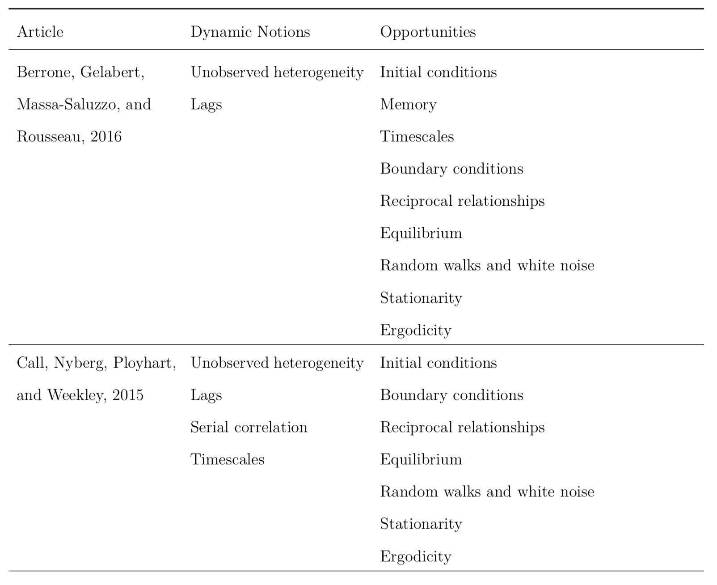

**TABLE 1**

**Recent studies exploring dynamic notions. (continued)**

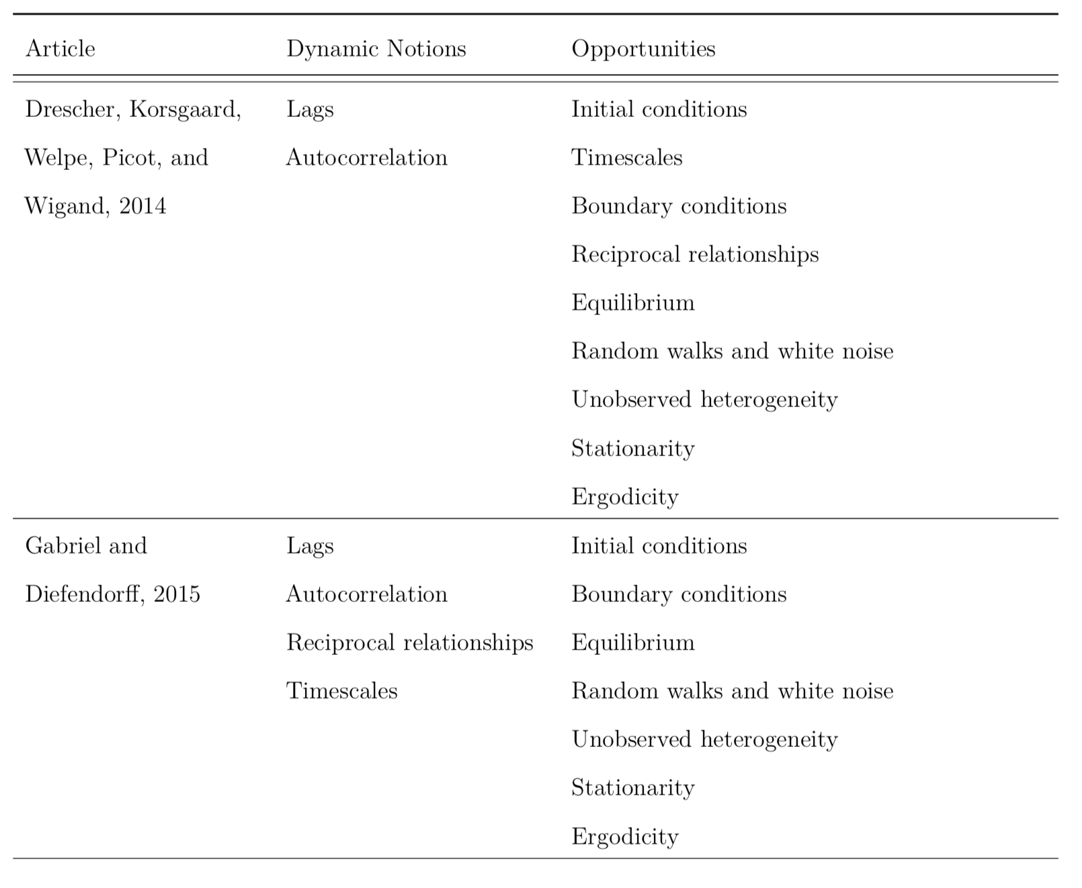

**TABLE 1**

**Recent studies exploring dynamic notions. (continued)**

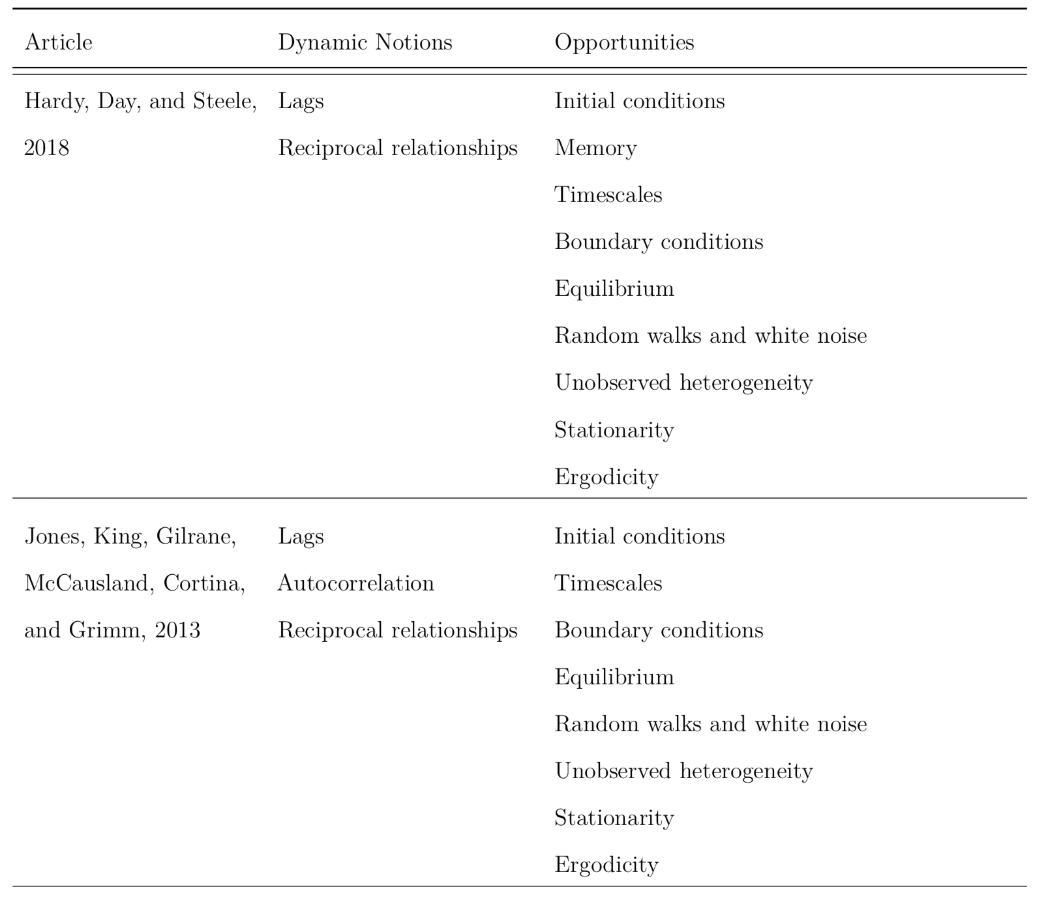

**TABLE 1**

**Recent studies exploring dynamic notions. (continued)**

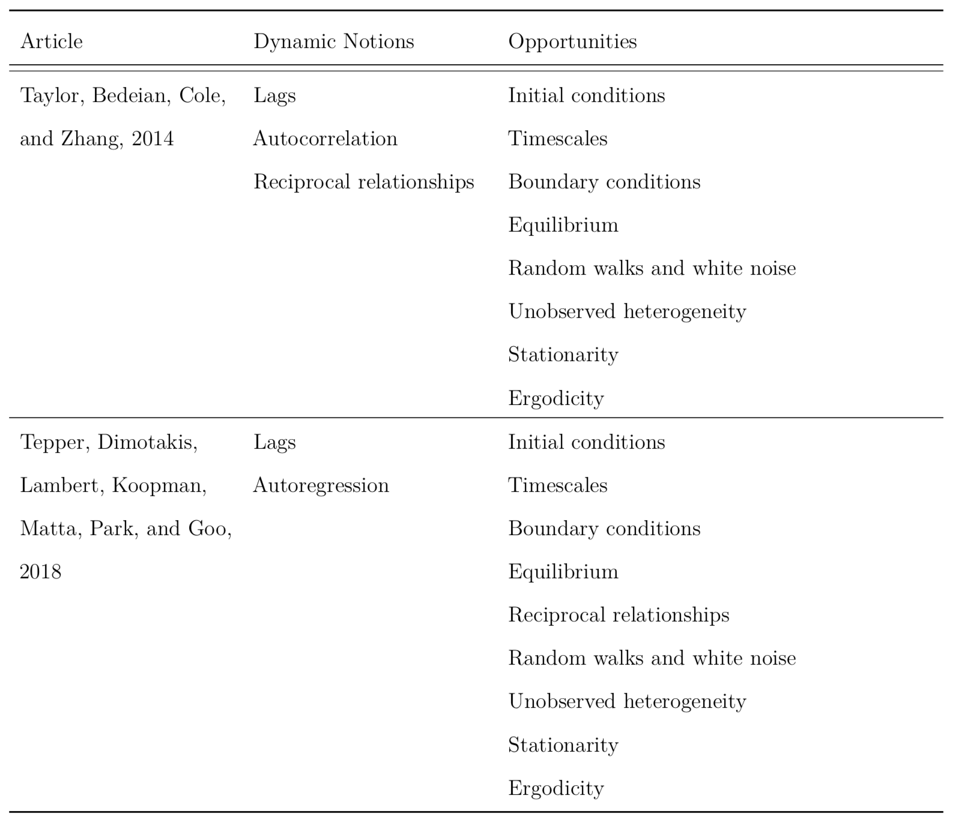

**FIGURE 1**

**Trajectories driving toward equilibrium or explosive behavior based on their autoregressive coefficients.**

[fig:unnamed-chunk-9]Trajectories driving toward equilibrium or explosive behavior based on their autoregressive coefficient. When the coefficient is greater than one (in absolute value) the trajectory oscillates explosively or grows exponentially. When the coefficient is between zero and one (in absolute value) the trajectory converges to equilibrium.[dynamics_plot]

Note. When the coefficient is greater than one (in absolute value) the trajectory oscillates explosively or grows exponentially. When the coefficient is between zero and one (in absolute value) the trajectory converges to equilibrium.

**FIGURE 2**

**Two fundamental stochastic processes: a random walk and white noise.**

[fig:unnamed-chunk-10]Two fundamental stochastic processes: a random walk and white noise.[noise]

1. [↑](#footnote-ref-1)